Crosstalk Cancellation
Version 1.0.0

Welcome
Thank you for downloading this fine plug-in. Crosstalk Cancellation is plugin that cancels crosstalk from the averted loudspeaker to each ear. The result is a headphone like listening situation without headphones.

In order to get the most out of the Crosstalk Cancellation, please spend a few moments reading this brief manual.

License
The pre-compiled Crosstalk Cancellation has a very simple license:

- Crosstalk Cancellation is freeware. This means that you are free to distribute it, give it to friends, or otherwise share it around. However, only the entire unaltered archive, including this document, may be re-distributed.
- Copyright of the code and the finished plug-in remain the property of the Delphi ASIO & VST Project and namely Christian-W. Budde.
- This plug-in is provided at no cost; therefore the author Christian-W. Budde assume no responsibility for any negative effects that may occur to the end user or the equipment used to run the plug-in.
Distance between the loudspeaker (1 cm - 5 m)
Crosstalk Filter Frequency
(20 Hz - 20 kHz )
Output Gain
(0 % - 100 %)
Attenuation
(-15 dB..0 dB)
Crosstalk Filter Gain
(0 % - 100 %)
Distance from the listener to (1 cm - 5 m)
Recursion Steps (1-16)
Bypass
- Magazine editors are welcome to include the plug-in on cover mount discs or similar media; however, I request that am informed about it via e-mail. A few copies of the publication are always appreciated, but not expected.

User Interface
The user interface shows all adjustable parameters and a readout for the characteristic curve. There are no meters available to maintain the lowest possible CPU usage without wasting too much CPU cycles. Either a dedicated analyse plugin or the build in meters can be used for this task.
Here is a commented screenshot:

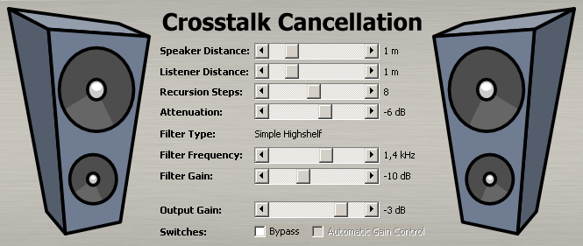

The sliders are identical to windows scroll bars. Drag them to the desired position or press the up/down buttons to change the value.

About Crosstalk Cancellation
In a normal stereo loudspeaker set-up there always exists crosstalk, which means the signal from the left speaker is audible on the right ear and vice versa. This is in contrast to a headphone environment, where the signal for the left signal can only be heard by the left ear.
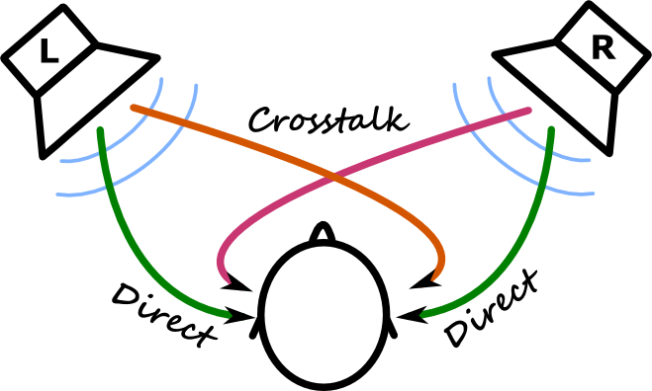
Normal music is mixed and mastered in a way to sound good on both stereo speakers and headphones with an emphasis on the typical stereo triangle set-up. The mixing/mastering engineer is supposed to be aware of the crosstalk effect. It can be expected that the crosstalk which will appear for the end consumer is tolerated and maybe even wanted.
Yet there are other types of music, such as binaural recordings, which are supposed to be listened via headphones. Furthermore some people prefer the clear, transparent sound of headphones to listen to any music. To achieve a similar sound via loudspeakers it becomes necessary to remove the crosstalk.
Early experiments have been done already in 1966 by Schroeder and Atal resulting in a patent (United States Patent 3236949). Later, especially with digital processing, more sophisticated methods were developed and used for different fields in the acoustic research.
However, all methods developed so far have a very simple principle in common. In order to remove the crosstalk, the expected crosstalk at the listeners ears is simulated and cancelled out by inverting its phase.
While this sounds simple in the first place it is quite tricky at the second glance.
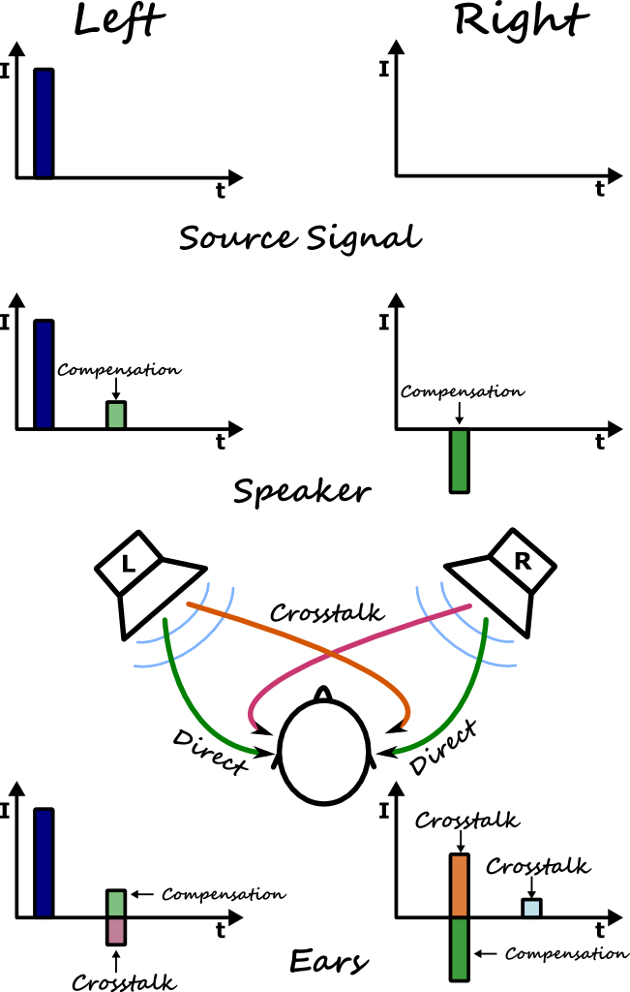
Let's consider a single impulse on the left speaker (source signal). In a normal stereo set-up, a small portion of this impulse is audible on the right speaker slightly delayed in time. In order to compensate this, the right speaker has to send out an delayed and phase inverted copy of this expected crosstalk signal to compensate it. However, by sending out this signal, it will surely also be slightly audible on the left channel as crosstalk. So the compensation signal for the right ear has to be compensated on the left ear by another compensation signal.
The left loudspeaker will now present the original signal and a compensation signal for the compensation signal on the right speaker. The right speaker only plays the compensation signal.
If we now have a look at the listeners ears we will find the source signal on the left as the only signal present. The crosstalk from the right ears compensation signal is perfectly cancelled out. On the right ear the cross talk from the left ear is entirely compensated. However, a small residual from the left speakers compensation signal can still be found as crosstalk. By repeating the compensation steps several times, it can be reduced even further.

The parameters
This plugin features 8 adjustable parameters.

Speaker Distance
With speaker distance you can tell the plugin the distance of your speakers. This is necessary to calculate the correction parameters correctly. The more error you have here the more impact it will have on high frequencies.

Listener Distance
With the listener distance you can tell the plugin where you (the listener) is located. The distance is measured from one (of the two) loudspeakers to you (assuming that your set-up is a perfect triangle). Again it is vitally important to be as close as possible, otherwise the effect isn't optimal. However, there exists a sweet spot even around this position, but the image might not be as wide as in the centre.

Recursion Steps
As explained above after the first step of compensation a residual crosstalk is still present. To remove this entirely, several steps must be performed recursively.

Attenuation
The amount of the effect can be controlled with this parameter. A value of 0 % means only the direct signal is used, while 100 % corresponds to a completely wet signal containing only the Crosstalk Cancellation effect.

Drift
The drift parameter is responsible for the relation of the stages to each other. While a drift value of 0 % means that all stages have an equal shift to each other higher values introduce unequal, random differences. As a result a light drift can sound more natural, while a drift of 0 % often sounds very transparent and clean. The 100 % setting should only be used for special effect as it sounds rather unstable.

Feedback / Bug Reports
I am always eager to hear feedback or have bugs reported. The easiest
way is to send me a mail to: Christian@aixcoustic.com

Furthermore feel free to download the source code, that can be found in the Delphi ASIO & VST Project at sourceforge.net.

Version History
  - First release!

Credits

• Programming: Christian W. Budde
• Additional Framework Programming: Tobias Fleischer, Maik Menz
• Special Thanks: Swen Müller, Duncan Parsons, Laurent de Soras
• Documentation based on a template by Greg Pettit

VST name and technology © Steinberg GmbH
The VST logo is a trademark of Steinberg GmbH

